Use cases examples with brief descriptions of features and step-by-step breakdown.

3.1 Workout Use Case

Use case: Select a Workout

**Diagram:**

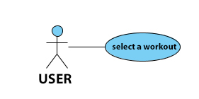

**Brief Description**

The user selects from list of available workouts desirable one.

**Initial Step-By-Step Description**

Before this use case can be initiated, the User has already open TopFit App.

1. The User selected Workout drop-down menu-button.

2. The System uses the Button_ListWorkuts to bring up the list of available workouts.

3. The user chose workouts that is available for him/her.

4. The System generates the list of exercises needed for this workout.

3.2 Delete Use Case

Use case: Delete Workout

**Diagram:**

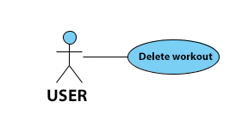

**Brief Description**

The user deletes a previously scheduled workout from a calendar.

**Initial Step-By-Step Description**

Before this use case can be initiated, the User has already open TopFit App.

1. The User selects Calendar menu-button.

2. The System uses the Button_Calendar to bring up the screen with calendar.

3. The User click on workouts on calendar that he/she want to delete.

4. The System generates warning message to user “You really want to delete this workout YESNO/” after selecting YES.

5. The System uses the Button_Delee_Workout to delete workout from user calendar.

3.3 Support Use Case

Use case: Contact a Technical Support

**Diagram:**

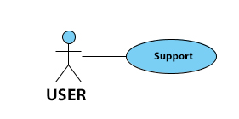

**Brief Description**

The user contacts a technical support when facing problem.

**Initial Step-By-Step Description**

Before this use case can be initiated, the User has already open TopFit App.

1. The User selected Support menu-button.

2. The System uses the Button_Support to bring up the Technical Support screen.

3. The user provide information about problem in text box and press Submit.

4. The System uses the Button_Support_Submit to generate ticket with a problem.

3.4 History Use Case

Use case: History

**Diagram:**

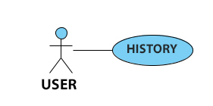

**Brief Description**

The user receives tracks of his/her daily activity.

**Initial Step-By-Step Description**

Before this use case can be initiated, the User has already open TopFit App.

1. The user selected History menu-button.

2. The System uses the Button_History to bring up the History screen.

3. The System generates history of user's daily activities.

3.5 Add Use Case

Use case: Add a Workout

**Diagram:**

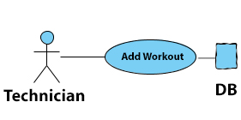

**Brief Description**

The technician adds new workout routine to the system.

**Initial Step-By-Step Description**

Before this use case can be initiated, the Technician has already open TopFit App.

1. The Admin (Technician) selected Add Workout menu-button.

2. The System uses the Button_Tech_Add_Workout to bring up the Add Workout screen.

3. The Admin(Technician) provide information about new workout and upload needed manual and press Submit.

4. The System uses the Button_Tech_Add_Workout_Submit to generate new workout in database.

**Activity Diagram Case #1**

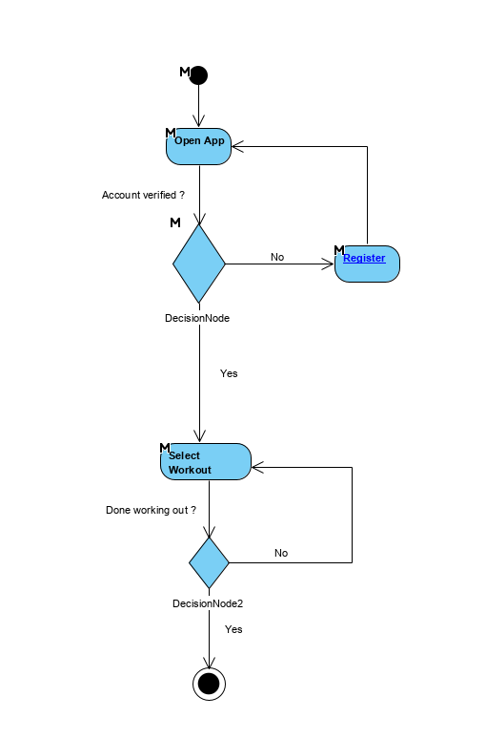

**Activity Diagram Case #2**

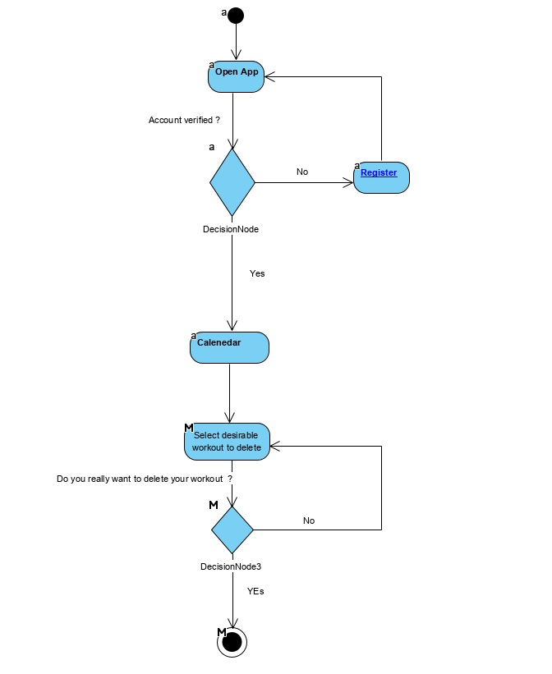

**Activity Diagram Case #3**

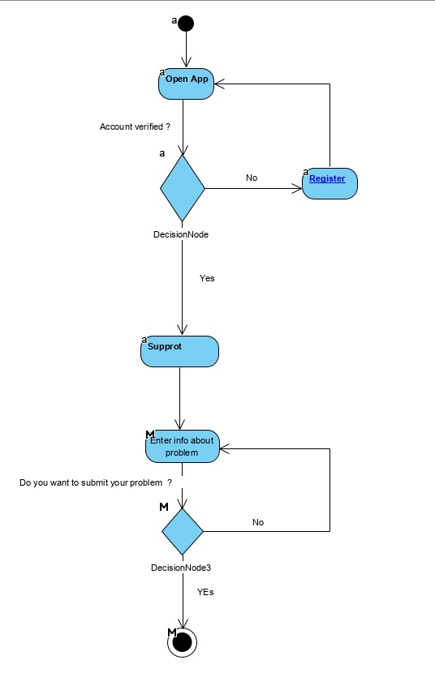

**Activity Diagram Case #4**

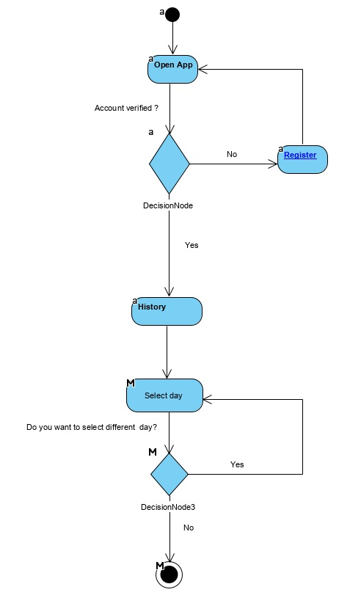

**Activity Diagram Case #5**

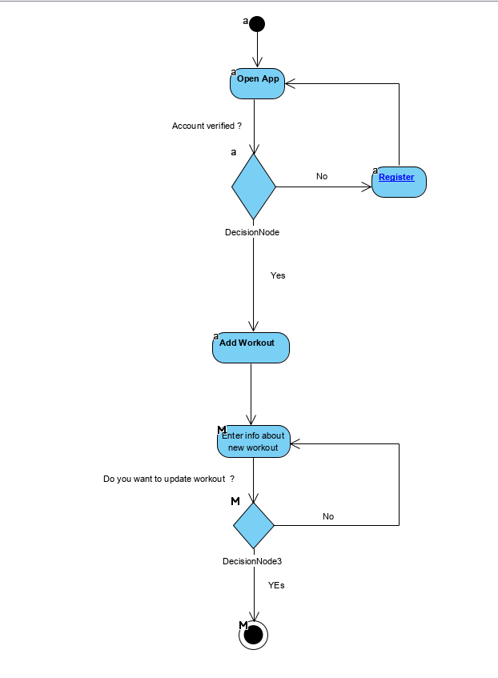

**Sequence Diagrams Case #1**

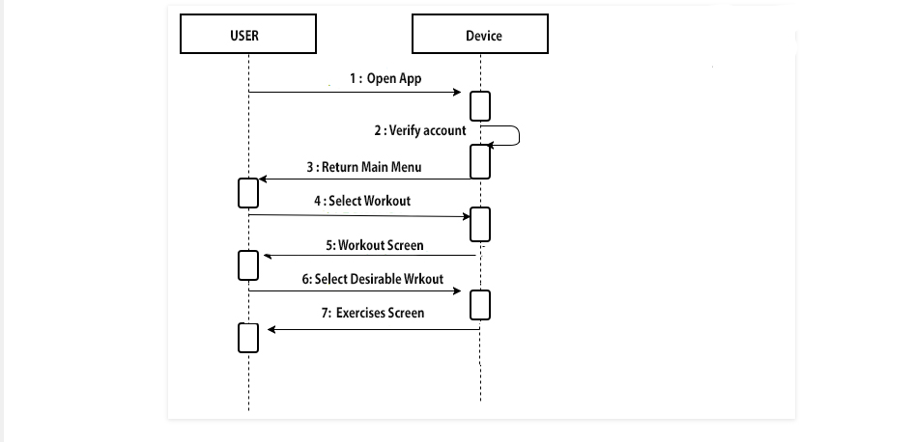

**Sequence Diagrams Case #2**

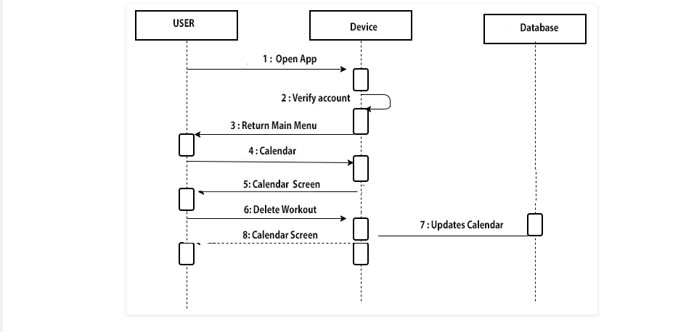

**Sequence Diagrams Case #3**

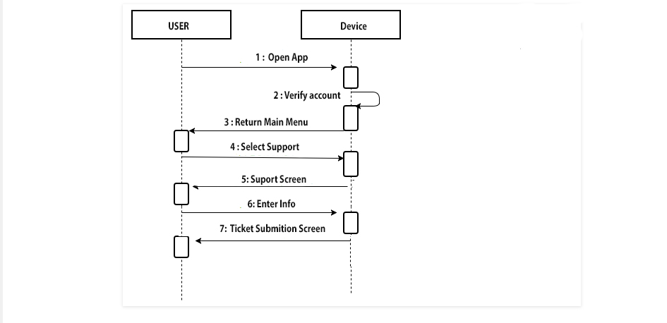

**Sequence Diagrams Case #4**

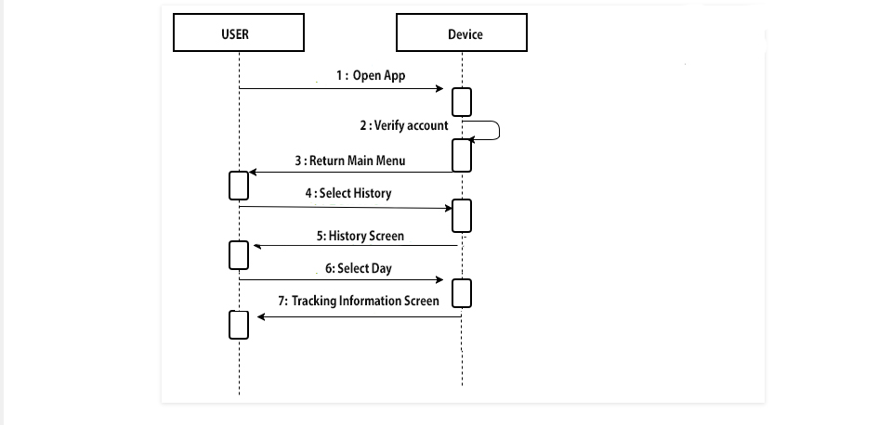

**Sequence Diagrams Case #5**

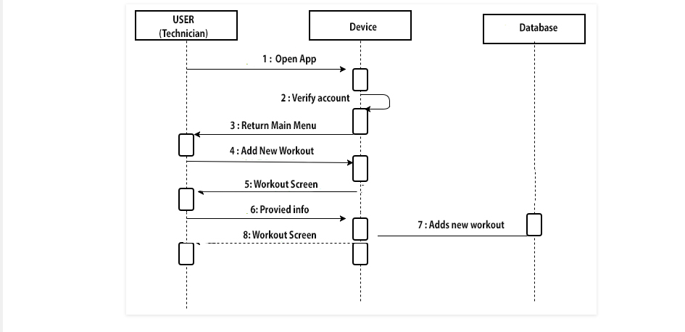

UML Class Diagram

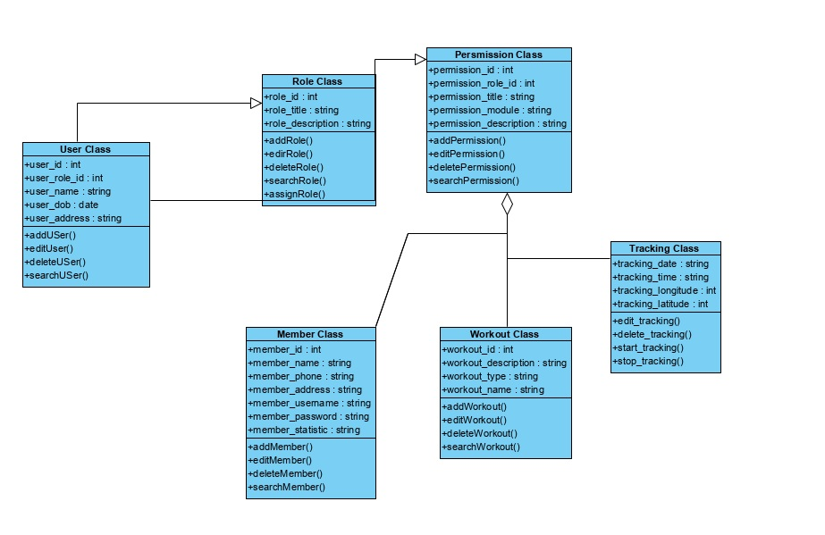

Normalized Data Model Diagram

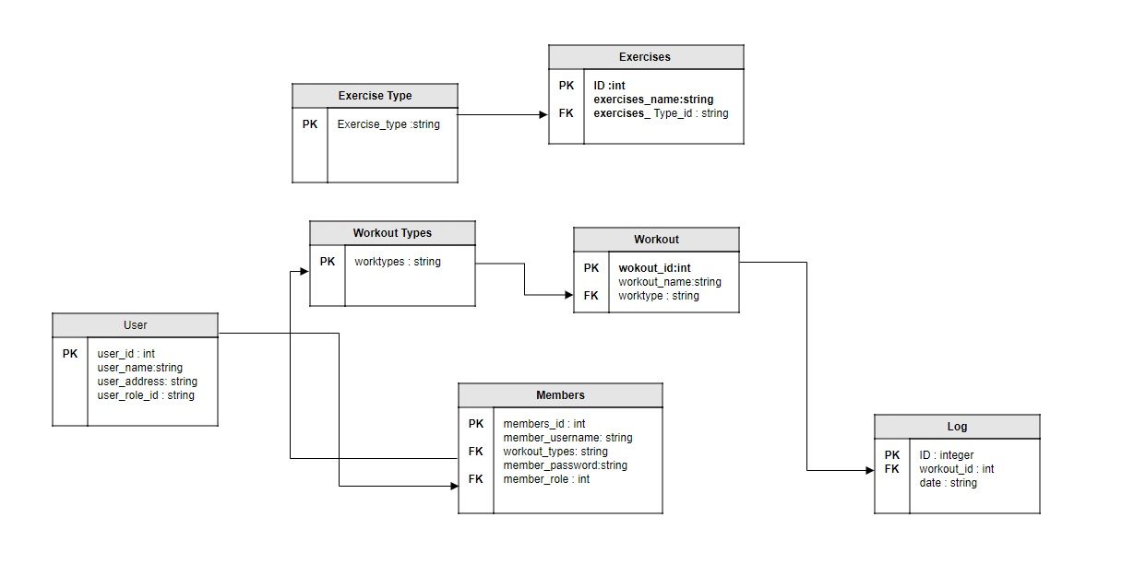

Data Flow Diagram

